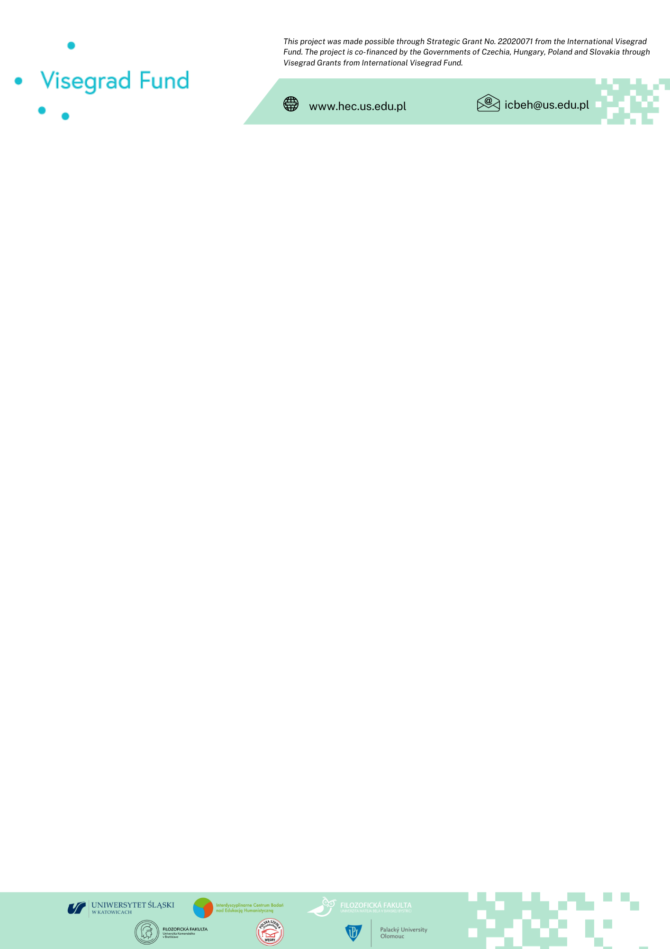
V4 Humanities Education for the Climate – Recommendations for Institutions Shaping Education

For three years (2020-2023), the Interdisciplinary Research Centre on Humanities Education at the University of Silesia in Katowice, together with partners from V4 countries: Matej Bel University in Banská Bystrica, Comenius University in Bratislava, Palacký University in Olomouc, as well as partners from Budapest – from the National Polish School in Hungary conducted research as part of the international project entitled The V4 Humanities Education for the Climate. Diagnoses – Best Practices – Recommendations [HEC]. The results of our activities, driven by concern for the climate and the fate of the Earth, implemented thanks to a grant from the International Visegrad Fund, allow us to formulate recommendations for humanistic climate education at the university and school levels.
It shall be emphasised that the main area of research and project activities were humanities subjects, with a special focus on language, literary and cultural education in all Visegrad Fund countries – Poland, Slovakia, the Czech Republic and Hungary, which stemmed from our belief that humanities education, so far underrepresented in the climate discourse, can speak out on the most critical issues concerning the future of our planet.
The project, which involves the activation of different audiences: academics, students, doctoral students, teachers working in primary and secondary schools and pupils, has almost explicitly shown that the pro-climatic expectations of all these groups are similar. These influenced the formulation of our proposals.

As part of climate education, we advocate as absolutely necessary:

- Introduction of climate and ecological education at all stages and levels of education, characterised by:
  - Interdisciplinary nature, taking into account new interpretative perspectives that unstiffen the traditional anthropocentric view of the world.
  - Participatory nature, with a profile created with experts and interested communities – including schools and universities.
  - The networking of humanistic climate-environmental education understood as establishing cooperative education systems at the university and school levels capable of responding rapidly to contemporary issues.
  - Establishment of climate and environmental education teams formed by scientists, teachers and experts (initiated by universities).
  - Initiation by higher education institutions of cooperation between academic and school environments, including teaching centres, in terms of training, tutor cooperation, development of materials, and exchange of good practices.
  - Appreciation of localness and the education associated with it.
  - Initiation of local activities involving representatives of different communities.
  - Incorporation of tangible solutions, a system of incentives and support for sustainable development (“green choices”, e.g. in relation to the use of water, energy sources, use of public transport, friendly educational spaces, dietary issues, critical reflection on consumerism) into climate and environmental education.
- Changes to curricula and educational methods
  - Changes to the core curricula in place at primary and secondary schools, with a particular focus on the core curriculum for humanities subjects in terms of taught content and reading lists, enabling the implementation of climate education.
  - Changes in university education systems in terms of study programmes and plans, interdisciplinarity of subjects, and graduation seminars (introduced with pro-climatic content in mind).
  - Changes in the training of future teachers of all subjects and classes to make them responsive guides in environmental education.
  - Revision of student teaching practice: in addition to the school, the apprenticeship of the future teacher should take place in climate education institutions, in contact with popularisers of interdisciplinary Traditional Ecological Knowledge, educators or psychologists.
  - Changes to the methodological technique at all levels of education: reduction of the bench system in favour of field education and meetings with experts. More action! The university could initiate such a change: organise courses, offer participation in shorter projects on climate issues or even excursions, field walks, lectures, and organise meetings with climate scientists. It is expected that the result of combining the knowledge, experience, and sensitivity of the academy and the school would be a deep cooperation between the academy and school, leading to an educational fusion for humanistic climate education. Such a vision of collaboration would fit perfectly into the very posthuman idea of relationality that we so desperately need.
- Introduction of programmes/courses to improve the preparation of teachers of all subjects and classes, as well as of university teachers (and support for such activities by universities and other institutions responsible for teacher education) in terms of:
  - Competence in the subject of environmental change.
  - Competence to skilfully stimulate in pupils/students an interest in the environment and shape their environmental sensitivity (empathy, sensitivity, attentiveness to nature) – using a different didactic technique, field education.
  - The competence to develop in pupils/students critical thinking, the skill of verifying scientific data and interpreting them (to recognise and separate true information on the state of the environment and climate from disinformation and attempts at manipulation).
  - The competence to develop attitudes of agency, commitment, responsibility and resilience. Agency, on the one hand, means introducing into the school/university the long-promised methodology of action, so far mostly limited by listening and talking, and on the other hand, the rather difficult attempt to take responsibility for the future of the world, since the content I teach or learn about and the attitudes that are shaped at school have an impact on the future of the Earth.
  - Strengthening proficiency in stimulating creativity to find solutions for reversing adverse climate change and coping with its progressive effects (adaptation to sudden climate changes).
  - Building and promoting collaborative, relational rather than competitive attitudes at all stages and levels of education.

The importance of the research carried out in the project by an international team of academics and school teachers as well as experts, the range of impacts (all Visegrad countries) and the results unquestionably indicate the relevance of the postulates and the need to implement them at all stages and levels of education.
In this sense, (humanities) climate education can become a framework for collective and hopeful thinking about the future of our planet and all beings.

The international team of researchers in the Visegrad Fund project
The V4 Humanities Education for the Climate. Diagnoses – Best Practices – Recommendations
(HEC, Project No. 22020071)

